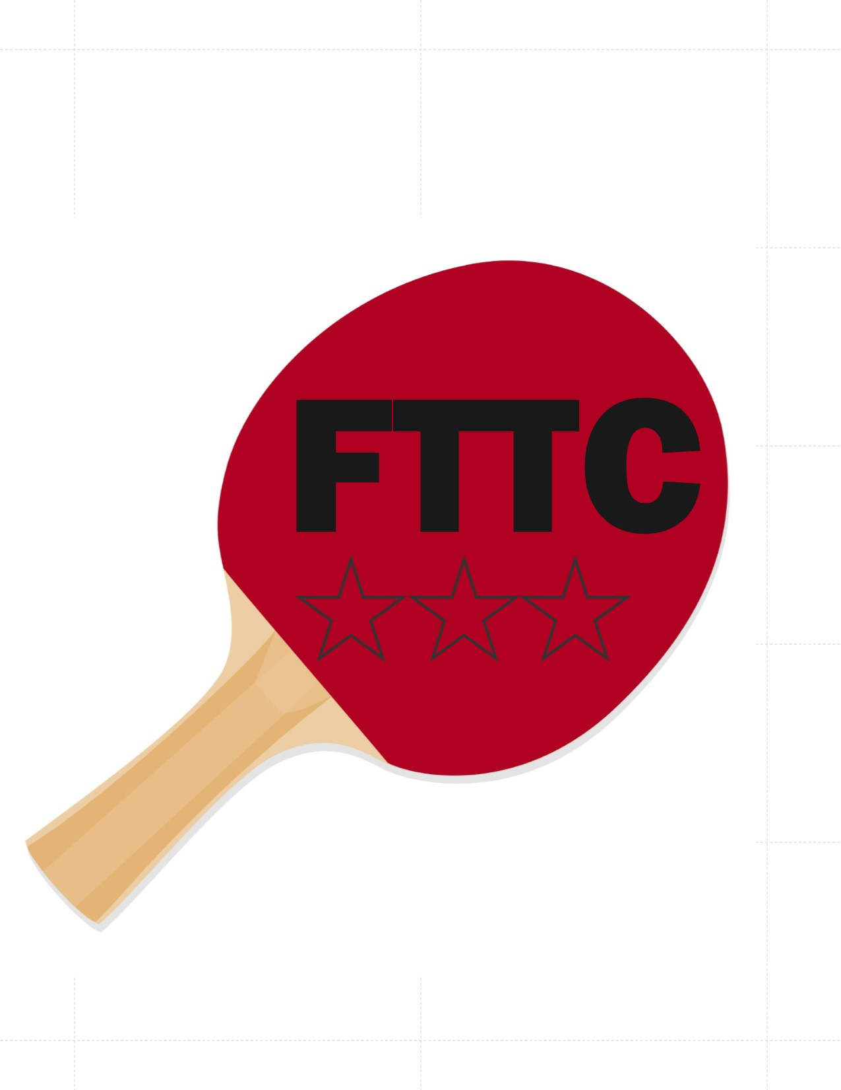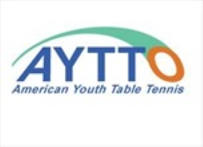

ITTF Level 2 Coaching Course
Dates: September 6 -8 and 13-15th, 2019
Location: Flushing Table Tennis Center 43-17 Union Street, Flushing NY 11355
Tel: 347-564-4142, 347-542-3700
Email: flushing.tabletennis@gmail.com Website: flushingtabletennis.com
Course Conductor:
ITTF Course Conductor/Trainer, Richard McAfee will conduct the course. Coach McAfee is an ITTF “Trainer” and one of the most experienced ITTF Course Conductors having conducted courses in many countries around the World.
Sydney Christophe, ITTF Coach/Conductor will serve as the local organizer.
Equipment: Seven (7) table tennis tables and balls will be used for the course.
Course Description:
The ITTF Level 2 Course is a 36-hour course normally held over six days while holding two (3-hour) sessions each day. The course material and syllabus can be found in the ITTF Advanced Manual. This material is a big step “up” from the ITTF Level 1 Course and it is highly recommended that all participants get a copy of the ITTF Advanced Manual and spend time in study before attending the course.
While the ITTF Level 1 Course is a general preparation course for coaches working with beginners and especially children, the Level 2 Course covers how to teach much higher level technical skills to fulfill the needs of athletes from 1800-2400 USATT Level.
ITTF Level 2 Course is officially recognized by ITTF and has the following requirements:
- Attendance at 36-hour course conducted by an ITTF approved Course Conductor
- Passing both a verbal and practical exam.
• Grading: The ITTF Level 2 Course offers much higher level of material than that found at the Level 1. There is a two-part test consisting of a verbal and practical exam. There are 10 possible points for both the Verbal and Practical Exams with a total of 20 for both. Coaches must score a minimum of 5 points on each of the two exams to pass the Level 2. Coaches scoring a minimum of 7 points on both exams with a total of 15 or more points are listed as Level 2* and are eligible to take an ITTF L3 Course in the future. Scores less than 5 on either exam do not pass the course.
- After the course, 50 hours coaching practice must be completed.
                - From the 50 hours, coaching practice, 5 hours must be supervised by the ITTF Course Conductor or a person appointed by the ITTF Course Conductor. This supervisor evaluates each coach using the “Confidential Coaching Report” This must be approved by the ITTF Course Conductor, who provides the certificates if all requirements are met.
Eligibility: Applications for the ITTF Level 2 Course are limited to coaches who meet the following requirements:
- Currently listed on the ITTF Coaches Registry as a Level 1 Coach
- Must have attended the ITTF Level 1 Course before September 6th, 2018 (1 year between courses)
Course Schedule:
- The ITTF Level 2 Course will be held September 6-8 and 13- 15th, 2019(2 weekends), There will be 2 sessions each day.
- Daily sessions are Fridays 11:00 am -2:00 pm & 3:00 pm- 6:00 pm-Saturdays and Sundays 1:00 pm -4:00 pm and 5:00 pm-8:00 pm
Costs: $355.00 per person plus each coach must purchase the ITTF Advanced Manual, available from PaddlePalace.com for $29.95. Coaches must have the manual with them during the course. Coaches are responsible for their own transportation and room and board arrangements
------------------------------------------------------------------------------------------------------------------------
Entry Form – ITTF/PTT Level 2 Course – FTTC- September 6- 8th & 13-15 2019. Course is limited to the first 20 entries received with deposit.
First name: _____________________ Last Name_________________________________________________
Street Address: _________________________________________________________ City: _____________________ ____
State: _____________ Zip: ___________________ Email: _____________________________________________________
Phone: __________________________ Are you currently a certified ITTF Level 1 Coach: (Y/N)
Date of ITTF Level 1 attended: ______________
Please make check payable to: Flushing Table Tennis Center ,43-17 Union Street, Flushing NY 11355
Please mail form and $150.00 deposit by 08/10 /2019 to: FTTC CO/ Sydney Christophe,

